Trefeglwys Community Council

Annual Report April 2023 – March 2024

website www.trefeglwyscc.com

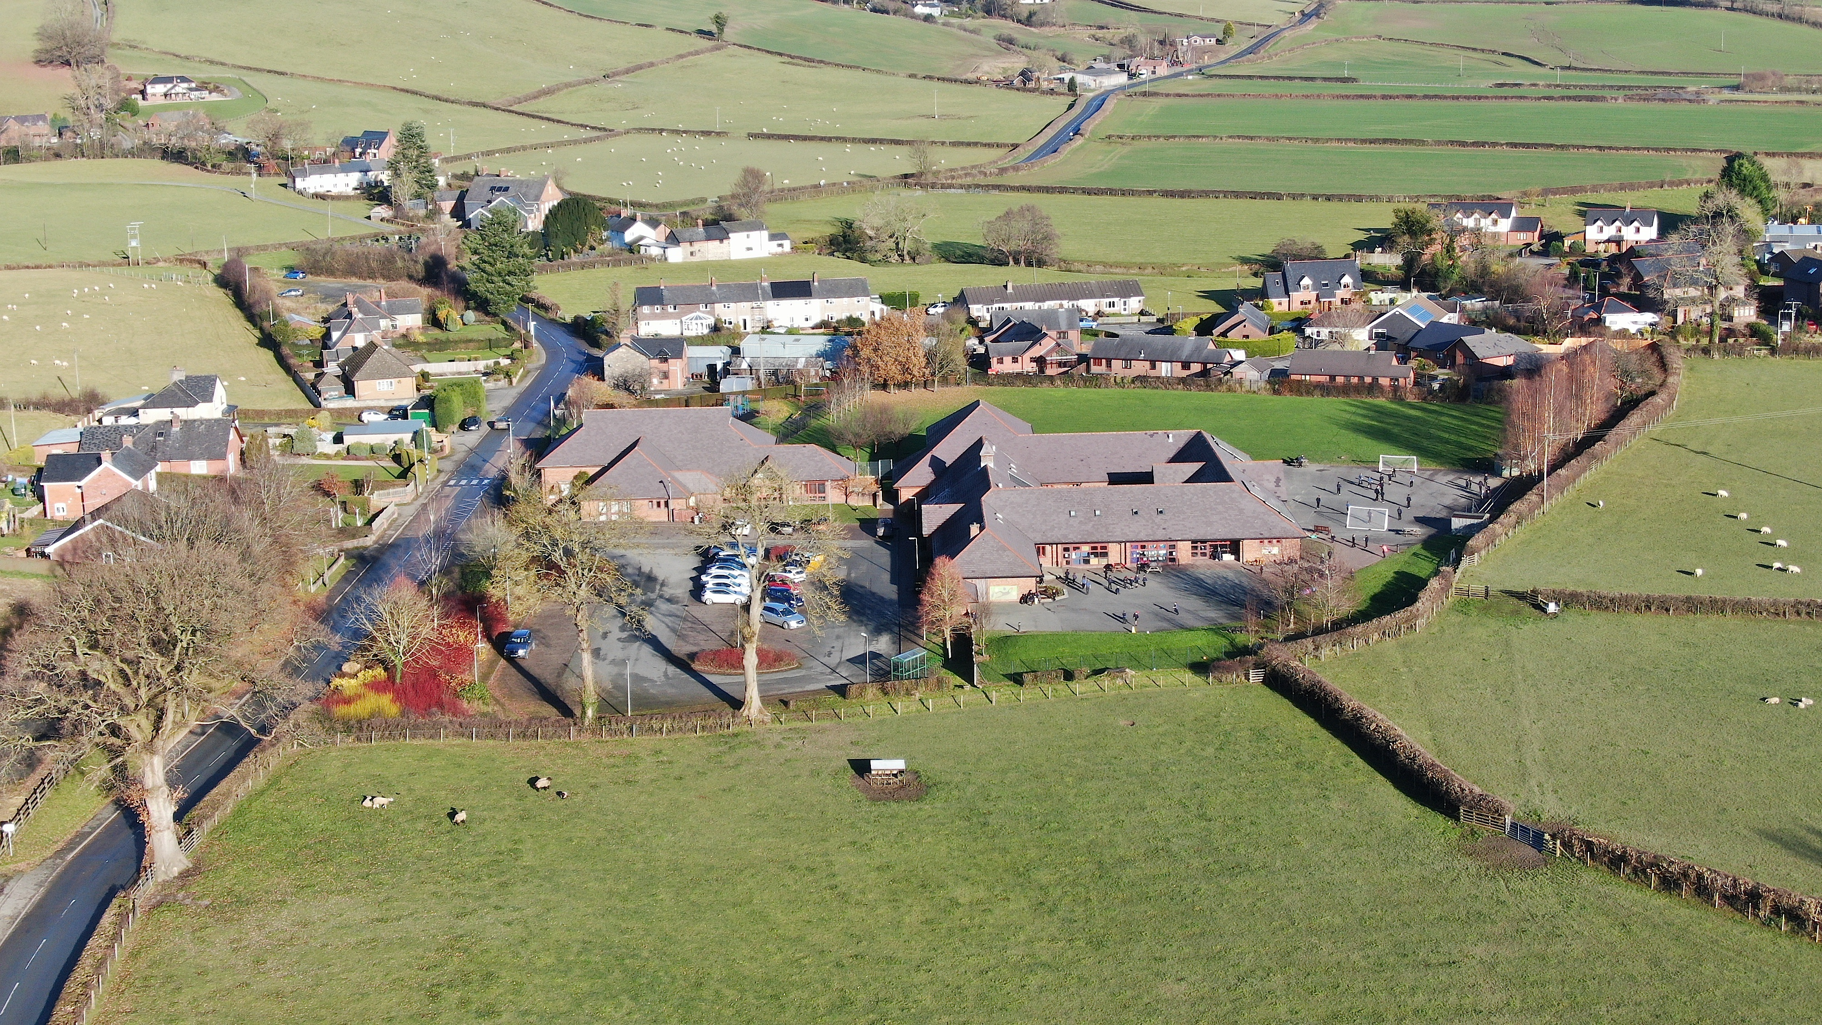

### Trefeglwys Community Council (the Council) is the first level of local government for the communities of Trefeglwys, Llawr-y-Glyn and Staylittle(Penforddlas). We represent approximately half of the newly established Powys County Council ward of Llanbrynmair. There are ten councillors, six representing Trefeglwys, two Llawryglyn and two Staylittle. All councillors are unpaid and currently waive their right to annual allowances and expenses even though significant costs are incurred, their details are available on the website, together with Council minutes and a wealth of local information. The website above crashed irretrievably and the Council is in the process of rebuilding a replacement, please be patient. The Council owns no property and employs only the Community Council Clerk.

Trefeglwys Community Council meets at the Trefeglwys Village Hall on the fourth Tuesday of each Month. All members of the community are very welcome to attend, or with five working days notice remote aural access can be arranged. Agendas & Minutes are posted on the website and on community noticeboards.

The Chair of the Council , Councillor David Jerman represents the Council at Ysgol Dyffryn Trannon where he serves as Chairman of the school governors.

Vice-Chair Councillor Paul Tranter resigned during the year and a decision on his replacement as Vice-Chair was deferred until the AGM in May.

Councillor Derrick Pugh took on the role of Press Officer as he is registered with the NPCC, as well as representing the Council on the Executive Committee of One Voice Wales, the organisation representing and supporting Community and Town Councils in Wales, he is also an elected member on the Policy Committee of One Voice Wales. During the year he has produced documentaries on The Wales Air Ambulance and the King’s Coronation celebrations amid others of local interest. He was also selected by the Public Services Ombudsman for Wales Office on two occasions to produce bilingual training films, one for Nick Bennett and secondly for the latest appointed Ombudsman Michelle Morris. These films are used for Code of Conduct Training for Town & Community Councillors throughout Wales.

Councillor Nick Bennett represented the Council with the Llawryglyn Village Association.

Councillor Ele Short represented the Council on the Trefeglwys Village Hall committee.

Councillor Jane Anwyl represented the Council on the Clywedog Community Association, Staylittle Village Hall.

We are pleased to welcome Mrs Heather Cockcroft as our new clerk and are grateful for her help. Thanks, must also go to Kat Holwill for her efforts in smoothing the transition of responsibilities.

The Council is naturally very concerned with the rising Council Tax bills and endeavours to keep their part of the burden to a minimum. In view of this the local precept (money paid by council tax payers) was maintained at £5,000 for 2023/24 or £ 9.73 for a band D property. Over the last 5 years we have managed to reduce the local Band D charge for Trefeglwys by 30%, during which time the Powys County Council charge has risen by 21%.

The Council administers a charitable fund fed by a local windfarm company Ventient Energy and during the year gave funds to Trefeglwys Village Hall, Clywedog Community Association and the Trefeglwys Eisteddfod. This fund also paid for replacement defibrillator pads at Trefeglwys (at The Red Lion) and at Llawryglyn and supported the establishment of a community library project in Trefeglwys. The fund also paid £1,000 towards the King’s Coronation celebrations. We are acutely aware that this fund should benefit all members of the community and try to act accordingly.

The Council has been recognised with another award (the fourth year in a row) from One Voice Wales, Commended for Community Engagement.

A significant amount of Council business concerns the state of the roads and planning applications with the clerk liaising with relevant PowysCC departments to relay Council’s concerns and opinions. The Council is still liaising with PowysCC to investigate the feasibility of the provision of local bus services through Trefeglwys, though this will not be resolved in the near future. Community concerns about windfarm pylons and a new proposed windfarm in Staylittle are also a focus of the Council. Maintenance of the three defibrillators, cemetery vandalism necessitating the planting of replacement trees, grass cutting, dog fouling, flower-boxes and footpaths also figure large.

The Council has noticed a worrying increase in trolling on social media locally and we would remind you that we are ordinary people doing our best for the community. Councillors in Wales have been advised that this is totally unacceptable and any such behaviour should be reported to the Police.

The Council was also pleased to supply material relating to another Freedom of Information (FOI) request regarding a local planning issue. As a result of this the Council became aware of derogatory comments made by our County representative, Councillor Gary Mitchell and have since asked him to attend meetings only by invitation.

The Council has consulted on many local and national consultations though the Council feels that their input is largely ignored. There is also a growing regulatory burden, with behaviour guides and increasing statutory regulation making the Councillor’s role ever more difficult. The current audit by Audit Wales is a good example with compliance proving very time-consuming and costly.

We are your local representatives, and you should feel free to contact us about any local concerns you have. Contact details are on the website for clerk and Councillors.

Would you like to be a Community Councillor when a vacancy or election arises?

For more information on the role of Community Councillors or becoming a Councillor visit

http://www.onevoicewales.org.uk/OVWWeb/become_a_councillor -7450.aspx or contact us.